

LCP Reporting System Installation Guide
(Installation Guide)
For
REPORTING SYSTEM of LCP
(ICOMM 1.0.0)

Document ID: ICOMM/LCP/Installation/1.00

Document developed by

Name | Revision | Date | Modified | Designation & Company | Approved by | Signature
G. Seshu Kumar | 1.00 | 12-04-2024 | Initial draft | Sr Manager, ICOMM | TBD | TBD
Jay Prakash | 1.01 | 28-12-2025 | - | Manager, ICOMM | TBD | TBD

Table of Contents
- Summary
- System Requirements
- Prerequisites and Dependencies
- Pre-Installation Checklist
- Installation Procedure and Step
- SQL Server 2022 Setup
- Database Configuration
- Application Installation
- Post-Installation Configuration
- Verification and Testing
- Troubleshooting
- Support and Maintenance

Summary
The LCP (Local Control Point) Reporting System is an enterprise-grade .NET application designed for comprehensive reporting and monitoring capabilities. This document provides step-by-step instructions for system administrators and IT personnel to install, configure, and deploy the application in production environments.
The installation process involves three primary components:
- Microsoft .NET Framework prerequisites
- SQL Server 2022 database infrastructure
- LCP Reporting System application
Estimated installation time: 45 minutes to 1 hour (depending on existing system configuration)

System Requirements

Hardware Requirements
Component | Minimum Requirement
Processor | Intel Core i5 (4 cores @ 2.0 GHz) or equivalent
RAM | 8 GB (16 GB recommended for production)
Hard Drive Space | 20 GB free (50 GB recommended)
Display | 1920 x 1080 minimum resolution
Network | Gigabit Ethernet (or wireless 802.11ac)

Table 1: Recommended hardware specifications
Software Requirements
Component | Version/Edition
Operating System | Windows Server 2016 SP2 or higher
 | Windows 10 (Build 1607) or higher
 | Windows 11
.NET Framework | 4.7.2 or later
SQL Server | 2022 Standard, Enterprise, or Developer Edition
SQL Server Management Studio | 19.0 or later (optional but recommended)

Table 2: Required software components
Network and Security Requirements
- Firewall Rules: TCP port 1433 (SQL Server default) must be open
- User Privileges: Administrator rights required for installation
- Domain Membership: Not required, but supported
- Internet Connectivity: Required during initial installation for updates
- SSL/TLS: Support for encrypted database connections

Prerequisites and Dependencies
.NET Framework Installation
SQL Server 2022 requires .NET Framework 4.7.2 or higher.
To verify your current .NET Framework version:
- Open PowerShell as Administrator
- Run the following command:
If .NET Framework 4.7.2 is not installed, download and install from the Microsoft Download Centre [1].
SQL Server 2022 Requirements
Operating System Prerequisites:
- Windows Server 2016 or later (recommended: Windows Server 2022)
- Windows 10/11 (for development or single-user installations)
Additional Prerequisites:
- .NET Framework 4.7.2 (installed automatically with SQL Server 2022)
- Disk space: Minimum 6 GB available
- RAM: Minimum 2 GB (4 GB recommended for database operations)
Runtime Components
The LCP Reporting System requires the following components:
- Windows Presentation Foundation () runtime libraries
- Visual C++ Redistributable packages
- Internet Explorer/Edge components (for certain rendering features)
These are automatically installed with the .NET Framework installation.

Pre-Installation Checklist
Before beginning the installation process, complete the following verification steps:
System Verification
- Verify operating system version and build number
- Confirm sufficient disk space (minimum 50 GB free)
- Ensure the system has at least 8 GB RAM available
- Verify network connectivity to the database server
- Check Windows Firewall rules for SQL Server ports
- Confirm administrator account availability
- Disable antivirus scanning during installation (temporary)
- Create system backup or snapshot
- Document current system configuration
- Identify database server location and credentials
User Account Requirements
- Service Account: Domain account or local account for SQL Server service
- Installation Account: Administrative privileges required
- Application Account: User account for running an application
- Service account must have directory permissions
- Application account requires read/write to the application directory
Network Configuration
Verify the following network settings:
Component | Required Configuration
SQL Server Host | Resolvable via DNS or HOSTS file
Network Protocol | TCP/IP enabled on SQL Server instance
Firewall Exception | Port 1433 (SQL Server) allowed inbound
Network Latency | < 100ms to database server (recommended)

Installation Procedure
The installation process follows three sequential phases:
Phase 1: System environment preparation and validation
Phase 2: SQL Server 2022 installation and configuration
Phase 3: LCP Reporting System application deployment
Installation Methods
The LCP Reporting System supports multiple installation methods:
Method 1: MSI Installer (Recommended)
- Provides a graphical user interface
- Automated prerequisite checking
- Silent installation support for enterprise deployments
- Rollback capabilities on failure
Method 2: Installation Procedure
- Right-click on the LCP Reporting System as shown screen below

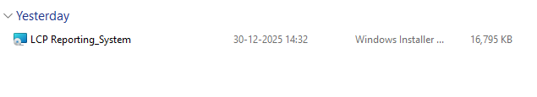
- Click on the open as shown screen below
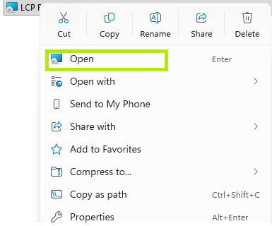

- The LCP reporting system welcome screen will appear as shown below in the screen. Click on the next button
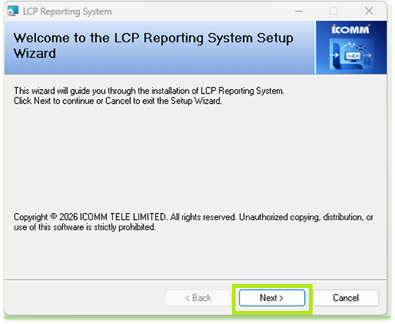

- The LCP reporting system License agreement screen will appear as shown below in the screen. The default selection in the license agreement is the “I Do Not Agree” option box user needs to select “I Agree” after reading the terms and conditions.

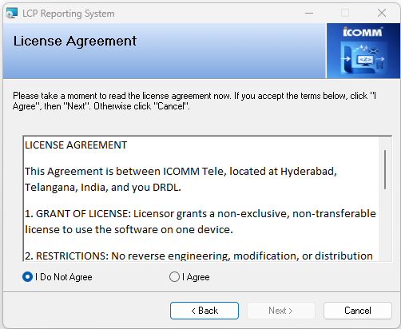

- The next button is enabled, and click on the Next Button, as shown below in the screen

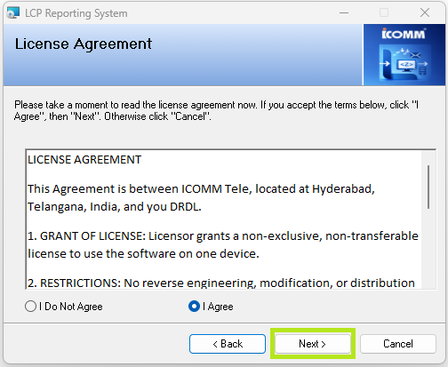

- The LCP reporting system READ ME screen will appear as shown below in the screen. PLEASE READ THIS AGREEMENT CAREFULLY BEFORE USING THIS SOFTWARE. Click on the Next button.

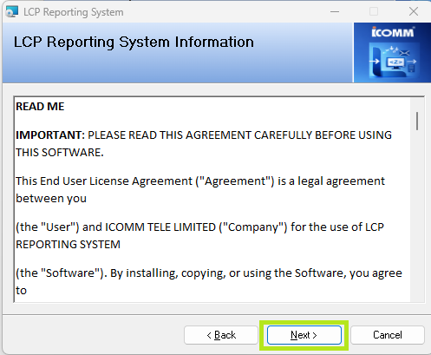

- The LCP reporting system Customer Information screen will appear as shown below in the screen.

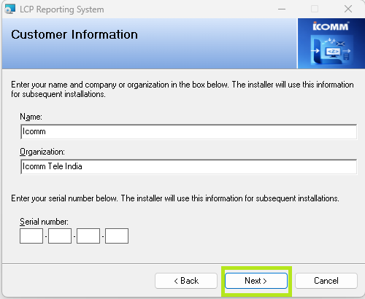
- The LCP reporting system Customer Information screen will appear as shown below in the screen. Enter the current Serial Number key in the serial number Text box.

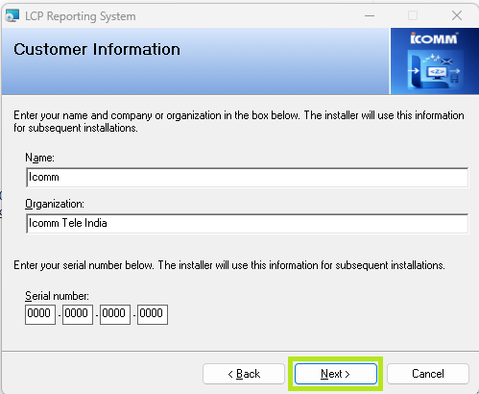

- The LCP reporting system confirms Information screen will appear as shown below in the screen. Click on the next button

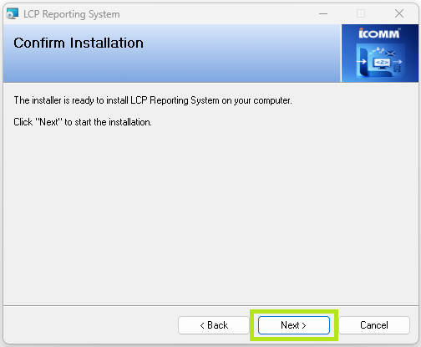
- The LCP reporting system Installation Reporting System Information screen will appear as shown below in the screen. after the progress bar is completed
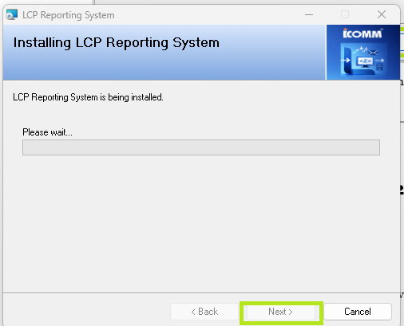
- The LCP reporting system Installation Reporting System Information screen will appear as shown below in the screen. After the progress bar is completed, the following screen will appear.
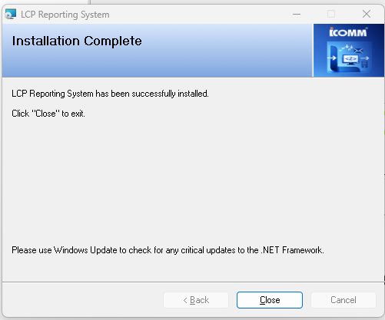
Click on the close button. LCP Reporting System installation is completed successfully, and the LCP Reporting System icon is created on the user's desktop, as shown below, and LCP Reporting System is shown in the control panel with the name of LCP Reporting System

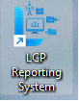
Double-click on the icon LCP Reporting System will run it successfully.

This guide focuses on MSI Installer deployment, the recommended method for production environments.

SQL Server 2022 Setup
Step 1: Download SQL Server 2022 Installation Media
- Visit the Microsoft SQL Server Download Centre [2]
- Select SQL Server 2022 from available versions
- Choose an appropriate edition:
  - Developer Edition: Unrestricted, free for development
  - Express Edition: Limited features, free
  - Standard/Enterprise: Production deployments, licensed
- Download the installation media (approximately 1.5 GB)
- Verify file integrity using the provided checksums
Step 2: Run SQL Server Installation Centre
- Mount or extract the SQL Server installation media
- Execute setup.exe from the media root directory
- Click Installation from the left navigation pane
- Select New SQL Server stand-alone installation
Step 3: SQL Server Setup Wizard Configuration
Setup Support Files:
- Click Install when prompted to install support files
- Allow the wizard to download required components from Microsoft
Installation Type:
- Select Perform a new installation of SQL Server 2022
- Click Next
Product Key:
- If using Developer/Express Edition, select free edition radio button
- For licensed editions, enter product key
- Click Next
License Terms:
- Accept the software license terms
- Click Next
Use Microsoft Update:
- Recommended to check for updates during setup
- Click Next
Step 4: Feature Selection
Select the following components for installation:
Database Engine Services (required)
SQL Server Replication (recommended for HA/DR)
Client Tools Connectivity (required for application)
SQL Server Management Tools (recommended)
Full-Text and Semantic Extractions (optional)
Do NOT install: Analysis Services, Reporting Services (unless required)
Click Next to continue.
Step 5: Instance Configuration
Default Instance Recommendation:
Setting | Value
Instance Type | Default Instance
Instance ID | MSSQLSERVER
Instance Root Directory | C:\Program Files\Microsoft SQL Server

Table 3: Instance configuration settings
For Named Instance (if multiple SQL Server instances required):
- Instance Name: LCPReporting (example)
- Instance ID: LCPREPORTING
- Connection string uses: SERVER=.\LCPREPORTING
Click Next to continue.
Step 6: Server Configuration
SQL Server Service Account:
- Select Use the same account for all SQL Server services
- Choose service account type:
- Built-in account: NT SERVICE\MSSQLSERVER (local service)
- Domain account: DOMAIN\ServiceAccount (recommended for production)
- If using a domain account, enter credentials:
- Account name: Domain\Username
- Password: Secure password (save in secure location)
- Click Next
SQL Server Agent Service:
- Set startup type to Automatic for automatic service restart
- Use the same account as the Database Engine Service
Additional Service Settings:
- Collation: SQL_Latin1_General_CP1_CI_AS (standard)
- Data Directory: C:\Program Files\Microsoft SQL Server\MSSQL16.MSSQLSERVER\MSSQL\DATA
- Log Directory: Same as Data Directory
Step 7: Database Engine Configuration
Authentication Mode:
- Windows Authentication Mode (recommended)
- Only Windows domain accounts can authenticate
- More secure, integrated with Windows security
- Select this option if using the domain infrastructure
- Mixed Mode (SQL Server and Windows Authentication)
- Allows SQL Server logins (sa account)
- Required for non-domain deployments
- Set a strong sa password if selected
Default Database Paths:
Path Type | Default Location
Data | C:\Program Files\Microsoft SQL Server\MSSQL16.MSSQLSERVER\MSSQL\DATA
Log | C:\Program Files\Microsoft SQL Server\MSSQL16.MSSQLSERVER\MSSQL\DATA
Backup | C:\Program Files\Microsoft SQL Server\MSSQL16.MSSQLSERVER\MSSQL\Backup
TempDB | (Use default locations)

Recommended Network Protocol Configuration:
- Enable SNMP/TCP/IP (required for client connections)
- Enable Named Pipes (for local network connections)
- Port number: 162,161 (standard)
Click Next to continue.
Step 8: Review Installation Summary
- Verify all selected components and configurations
- Confirm feature selection matches requirements
- Check installation directory paths
- Review feature configuration summary
Click Install to begin installation.
Step 9: Installation Progress and Completion
- Installation typically takes 5-10 minutes
- Monitor progress in the installation wizard
- Allow system to restart if prompted
- Do not interrupt the installation process
Once completed, verify installation by opening SQL Server Management Studio and connecting to the new instance.

Database Configuration
SQL Server Management Studio Connection
- Open SQL Server Management Studio (SSMS)
- In the Connect to Server dialogue:
  - Server name: .\MSSQLSERVER (for default instance) or .\LCPREPORTING (for named instance)
  - Authentication: Windows Authentication
  - Click Connect
Create LCP Reporting Database
-- Create LCP Reporting database
USE master;
GO
CREATE DATABASE [LCPReporting]
CONTAINMENT = NONE
ON PRIMARY (
NAME = N'LCPReporting',
FILENAME = N'C:\Program Files\Microsoft SQL Server\MSSQL16.MSSQLSERVER\MSSQL\DATA\LCPReporting.mdf'
)
LOG ON (
NAME = N'LCPReporting_log',
FILENAME = N'C:\Program Files\Microsoft SQL Server\MSSQL16.MSSQLSERVER\MSSQL\DATA\LCPReporting_log.ldf'
);
GO
-- Set database properties
ALTER DATABASE [LCPReporting] SET COMPATIBILITY_LEVEL = 160;
GO
Database User Creation
-- Create database user for application
USE [LCPReporting];
GO
-- For Windows Authentication
CREATE USER [DOMAIN\AppServiceAccount]
FOR LOGIN [DOMAIN\AppServiceAccount];
GO
-- Grant necessary permissions
ALTER ROLE [db_owner] ADD MEMBER [DOMAIN\AppServiceAccount];
GO
-- For SQL Server Authentication (if using mixed mode)
CREATE LOGIN [LCPReportingUser] WITH PASSWORD = N'P@ssw0rd!';
GO
CREATE USER [LCPReportingUser] FOR LOGIN [LCPReportingUser];
GO
ALTER ROLE [db_owner] ADD MEMBER [LCPReportingUser];
GO
Execute Database Schema Script
- Open database deployment script: LCPReporting_Schema.sql
- In SQL Server Management Studio:
  - Connect to LCPReporting database
  - Open Query window (Ctrl+N)
  - Paste script content
  - Execute (F5)
- Verify successful table creation in Object Explorer
Backup Database Configuration
Create a regular backup strategy:
-- Configure backup location
EXEC xp_create_subdir N'C:\Backups\LCPReporting';
GO
-- Create full backup (to be scheduled in SQL Agent)
BACKUP DATABASE [LCPReporting]
TO DISK = N'C:\Backups\LCPReporting\LCPReporting_Full.bak'
WITH INIT, COMPRESSION, STATS = 10;
GO

Application Installation
Pre-Installation Requirements
Before installing the LCP Reporting System application, verify:
- .NET Framework 4.7.2 or later is installed
- SQL Server 2022 instance is running and accessible
- Database user account has appropriate permissions
- Database schema has been initialized
- Windows Firewall allows executable applications
- Antivirus software is configured or temporarily disabled
MSI Installation Package Preparation
- Obtain the LCP Reporting System MSI installer package
- Verify file integrity:
  - File: LCPReportingSystem_v1.0.msi (approximately 150 MB)
  - Check SHA256 hash matches release notes
- Copy the installer to a secure location on the target system
- Create a separate directory for installation: C:\Program Files\ICOMM\LCPReporting\
Execute MSI Installation
- Double-click LCPReportingSystem_v1.0.msi to launch the installer
- If prompted by Windows Security, click Install or Run
- The installation wizard window opens with the license agreement
Installation Wizard Steps
Step 1: Welcome Screen
- Review product name and version information
- Click Next to proceed
Step 2: License Agreement
- Read license terms carefully
- Accept terms by clicking I Accept the terms in the License Agreement
- Click Next
Step 3: Installation Type
- Typical Installation (recommended)
- Installs all components with default settings
- Automatic configuration of settings
- Custom Installation
- Allows component-level selection
- Manual configuration options
- Complete Installation
- Includes optional documentation and examples
Select Typical Installation and click Next.
Step 4: Database Connection Configuration
Enter SQL Server connection details:
Setting | Value
Server Name | .\MSSQLSERVER or IP address
Instance Name | Default or named instance
Database Name | LCPReporting
Authentication | Windows / SQL Server
Username | (if SQL authentication)
Password | (if SQL authentication)

- Test connection by clicking the Test Connection button
- Message should confirm: "Connection successful"
- Click Next
Step 5: Application Settings
Configure application parameters:
Setting | Value | Description
Installation Path | C:\Program Files (x86) \ICOMM\LCP Reporting System | Base directory
Start Menu Folder | LCP Reporting | Program menu folder
Enable Auto-Update | Yes/No | Check for updates
Logging Level | Info/Debug | Event logging detail
Report Export Path | C:\Reports | Output directory

Table 4: Application configuration settings
Click Next to continue.
Step 6: Ready to Install
- Review installation summary
- Verify all settings are correct
- Change any settings using the Back button if needed
- Click Install to begin installation
Installation Progress
- Installation progress bar displays completion percentage
- Typical installation time: 3-5 minutes
- System performs the following operations:
  - Extracts application files
  - Creates Windows registry entries
  - Installs start menu shortcuts
  - Creates data directories
  - Initializes application configuration files
  - Registers runtime components
Installation Completion
Upon successful completion:
- The Finish Screen is displayed with a completion message
- Click Finish to close the installer
- Installer optionally launches the application immediately
- Check Launch LCP Reporting System to open the application
- Application window opens with login screen

Post-Installation Configuration
Application Configuration File Setup
The application configuration file is located at:
C:\Program Files\ICOMM\LCPReporting\app.config
Default connection string format:
For named instance:
connectionString="Server=.\LCPREPORTING;Database=LCPReporting;Integrated Security=true;"
For remote SQL Server:
connectionString="Server=SQL-SERVER-IP-ADDRESS;Database=LCPReporting;Integrated Security=true;"
Application User Accounts
Create Application User in Windows:
- Open Local Users and Groups (lusrmgr.msc)
- Create new user: LCPReportingUser
- Set password (strong, non-expiring for service accounts)
- Add user to Users group (no admin required)
- Grant permissions to the application directory:
  - Path: C:\Program Files\ICOMM\LCPReporting
  - Permissions: Read, Execute, Modify
  - Ownership: LCPReportingUser
Logging and Event Tracing
Configure application logging:
- Navigate to: C:\Program Files\ICOMM\LCPReporting\config\logging.config
- Set logging level:
- Configure log file location:
- Create log directory: mkdir C:\Logs (with user permissions)
- Restart the application for the changes to take effect
Firewall Configuration
Configure Windows Firewall to allow the application:
Via Control Panel:
- Open Windows Defender Firewall → Advanced Settings
- Click Inbound Rules → New Rule
- Configure rule:
  - Rule type: Program
  - Program path: C:\Program Files\ICOMM\LCPReporting\LCPReporting.exe
  - Action: Allow
  - Direction: Inbound
  - Profiles: Domain, Private, Public
- Click Finish to enable the rule
Via PowerShell (Administrator):
New-NetFirewallRule -DisplayName "LCP Reporting System" -Direction Inbound
-Program "C:\Program Files\ICOMM\LCPReporting\LCPReporting.exe" `
-Action Allow
SQL Server Connection Verification
Test database connectivity from the application:
- Launch LCP Reporting System application
- In application menu: Tools → Database Connection Test
- Enter connection parameters (if not auto-detected)
- Click Test Connection
- Confirmation message: "Database connection successful"
If the connection fails, verify:
- SQL Server service is running: services.msc
- Correct server name and instance specified
- User account has database access permissions
- Network firewall allows SQL Server port (1433)

Verification and Testing
Post-Installation Verification Checklist
- Verify the application shortcut created in the Start Menu
- Launch the application from the Start Menu shortcut
- Application window opens without errors
- Database connection established successfully
- User authentication login functionality works
- Application toolbar and menus displayed correctly
- Sample report loads from the database
- Report generation completes without errors
- Export to PDF/Excel functionality works
- Application settings are accessible and configurable
- Help system accessible (F1 key or Help menu)
- Application closes cleanly without errors
Database Schema Verification
Verify database objects were created successfully:
-- Check tables
SELECT TABLE_NAME FROM INFORMATION_SCHEMA.TABLES
WHERE TABLE_SCHEMA = 'dbo'
ORDER BY TABLE_NAME;
GO
-- Check stored procedures
SELECT ROUTINE_NAME FROM INFORMATION_SCHEMA.ROUTINES
WHERE ROUTINE_SCHEMA = 'dbo'
AND ROUTINE_TYPE = 'PROCEDURE'
ORDER BY ROUTINE_NAME;
GO
-- Check views
SELECT TABLE_NAME FROM INFORMATION_SCHEMA.VIEWS
WHERE TABLE_SCHEMA = 'dbo'
ORDER BY TABLE_NAME;
GO
-- Verify row counts in key tables
SELECT TABLE_NAME, (SELECT COUNT(*) FROM dbo.Reports) AS ReportCount
FROM INFORMATION_SCHEMA.TABLES
WHERE TABLE_NAME = 'Reports';
GO
Performance Baseline Testing
Establish baseline performance metrics:
Test Scenario | Expected Result | Actual Result
Application startup time | < 5 seconds | _____
Login completion | < 2 seconds | _____
Report generation (100k rows) | < 10 seconds | _____
Export to PDF (1000 records) | < 3 seconds | _____
Database query (simple) | < 1 second | _____
Memory usage at idle | < 200 MB | _____

Document baseline metrics in system runbook for future reference.

Troubleshooting
Common Installation Issues
Issue 1: ".NET Framework 4.7.2 not found"
Solution:
- Download .NET Framework 4.7.2 from Microsoft Download Center[1]
- Run the installer before attempting LCP Reporting installation
- Restart the system after the .NET Framework installation
- Retry LCP Reporting System installation
Issue 2: "SQL Server 2022 installation fails with prerequisites error"
Solution:
- Run Windows Update and install all critical updates
- Restart the system
- Disable Windows Defender/antivirus temporarily
- Run SQL Server setup as Administrator (right-click → Run as administrator)
- Check C:\Program Files\Microsoft SQL Server[VERSION]\Setup Bootstrap\Log\Summary.txt for details
Issue 3: "Database connection failed - Server not found"
Causes and solutions:
- Server name incorrect: Verify with OSQL -L command to list local SQL instances
- SQL Server service not running: Start from Services (services.msc)
- Network connectivity issue: Test with sqlcmd -S .\MSSQLSERVER -E (with trusted connection)
- Firewall blocking port 1433: Check Windows Firewall inbound rules for SQL Server
Issue 4: "Access denied - insufficient permissions"
Solution:
- Verify the user account has database permissions:
SELECT * FROM sys.database_principals
WHERE name = 'DOMAIN\AccountName'
- Grant required permissions:
ALTER ROLE [db_owner] ADD MEMBER [DOMAIN\AccountName];
- Run the application as the account with proper permissions
LCP Application Troubleshooting
Application crashes on startup:
- Check Event Viewer (eventvwr.msc) Application logs for errors
- Review application log file: C:\Users\Useraccount\Documents\LCP\logs.log
- Verify all required assemblies are present in the installation directory
- Run application in compatibility mode (right-click properties)
SQL Server Troubleshooting
SQL Server service won't start:
- Check SQL Server error log:
C:\Program Files\Microsoft SQL Server\MSSQL16.MSSQLSERVER\MSSQL\LOG\ERRORLOG
- Verify service account credentials are correct:
  - Services → SQL Server (MSSQLSERVER) → Properties → Log On tab
  - Test login credentials
- Verify disk space available:
Get-Volume C: | Select-Object SizeRemaining, Size
- Restart SQL Server: net stop MSSQLSERVER and net start MSSQLSERVER
High memory usage by SQL Server:
- Monitor memory usage: Task Manager → Performance tab
- Query memory consumption:
SELECT * FROM sys.dm_exec_query_memory_grants
WHERE grant_time IS NOT NULL;
- Reduce buffer pool: Restart SQL Server with reduced memory allocation
Support and Maintenance
Regular Maintenance Tasks
Daily Tasks:
- Monitor SQL Server error logs for warnings
- Verify backup completion messages
- Check the application log file for errors
- Monitor disk space usage
Weekly Tasks:
- Review SQL Server Agent job status
- Verify full backup completion
- Check application performance metrics
- Review user access logs
Monthly Tasks:
- Update SQL Server with the latest patches
- Verify disaster recovery procedure
- Review database growth trends
- Audit user permissions and access
- Update documentation with changes
Backup and Recovery Procedures
Full Database Backup Schedule:
-- Create scheduled backup (SQL Server Agent)
EXEC sp_add_schedule
@schedule_name = 'LCPReporting_Backup_Daily',
@freq_type = 4,
@freq_interval = 1,
@active_start_time = 020000;
EXEC sp_attach_schedule
@job_name = 'LCPReporting_Daily_Backup',
@schedule_name = 'LCPReporting_Backup_Daily';
Backup Retention Policy:
- Full backups: Daily, retain 30 days
- Transaction log backups: Hourly, retain 7 days
- Location: C:\Backups\LCPReporting\
- Offsite copy: Weekly to network share or cloud storage
Database Restoration:
-- Restore from full backup
RESTORE DATABASE [LCPReporting]
FROM DISK = N'C:\Backups\LCPReporting\LCPReporting_Full.bak'
WITH NORECOVERY, REPLACE, STATS = 10;
-- Restore transaction logs to a specific point in time
RESTORE LOG [LCPReporting]
FROM DISK = N'C:\Backups\LCPReporting\LCPReporting_Log.trn'
WITH RECOVERY;
Update and Patching Strategy
SQL Server Updates:
- Monitor Microsoft security bulletins
- Test updates in the non-production environment first
- Schedule maintenance window with stakeholders
- Apply updates during off-hours
- Verify application functionality after update
- Keep patch history documentation
Application Updates:
- Review release notes and known issues
- Create a backup before updating
- Execute update installer (MSI)
- Verify database schema compatibility
- Test critical functionality
- Update runbook documentation
Performance Monitoring
SQL Server Performance Counters:
Buffer Cache Hit Ratio (target > 99%)
Page Life Expectancy (target > 300 seconds)
Transactions per second
Log bytes flushed per second
CPU utilization (sustained < 70%)
Disk I/O reads and writes
Number of active connections
Monitor using SQL Server Management Studio:
- Object Explorer → Management → Activity Monitor
- Displays current active connections and processes
- Review query execution plans for slow queries
- Identify blocking and deadlock situations
Documentation References
Internal Documentation:
- LCP Reporting System User Manual
- System Architecture and Design Document
- Database Schema Reference Guide
- API Integration Guide
- Security and Access Control Policy
Microsoft Documentation:
- SQL Server 2022 Documentation[3]
- .NET Framework 4.7.2 Reference[4]
- Developer Guide[5]
- Windows Installer (MSI) Best Practices[6]

Appendices
Appendix A: Connection String Examples
Default Instance with Windows Authentication:
Server=.\MSSQLSERVER;Database=LCPReporting;Integrated Security=true;
Named Instance with Windows Authentication:
Server=.\LCPREPORTING;Database=LCPReporting;Integrated Security=true;
Remote Server with Windows Authentication:
Server=SQL-SERVER-IP-OR-HOSTNAME,1433;Database=LCPReporting;Integrated Security=true;
SQL Server Authentication:
Server=.\MSSQLSERVER;Database=LCPReporting;User ID=sa;Password=YourPassword;
Encrypted Connection:
Server=.\MSSQLSERVER;Database=LCPReporting;Integrated Security=true;Encrypt=true;TrustServerCertificate=false;
Appendix D: Glossary of Terms
ICOMM: Integrated Command and Control Management System
LCP: Local Control Point - enterprise control terminal module
: Windows Presentation Foundation - Microsoft .NET UI framework
MSI: Microsoft Installer - standard Windows package format
MSSQLSERVER: Default SQL Server instance name
Database Engine: Core SQL Server relational database service
Authentication Mode: Security method for database access (Windows or Mixed)
Service Account: Windows account used to run SQL Server services
Connection String: Configuration parameters for database connectivity
Integrated Security: Windows Authentication using logged-in user credentials
Rollback: Automatic undo of installation on failure

Windows Service Configuration for Sub System Non-Trap Information.

SNMPWalkService-Deploying a .NET Windows service named SNMPWalkService involves publishing the executable and registering it with Windows using command-line tools. Use administrative privileges for installation, and ensure the service code includes builder.Host.UseWindowsService() for proper hosting. This works for both .NET Framework and .NET Core/5+ Worker Services.

Prerequisites
Verify the service project targets Windows with the Microsoft.Extensions.Hosting.WindowsServices NuGet package added. Publish as self-contained for production: dotnet publish -c Release -r win-x64 --self-contained -o C:\SNMPWalkService\publish (adjust runtime as needed). Confirm SNMPWalkService.exe exists in the output folder.

Install with SC Command
Open Command Prompt or PowerShell as Administrator and run: sc create SNMPWalkService binPath= "C:\SNMPWalkService\publish\SNMPWalkService.exe" start= auto. The space after binPath= is required; use quotes for paths with spaces. Set optional description: sc description SNMPWalkService "SNMP Walk monitoring service". Start it: sc start SNMPWalkService.
Management Commands
- Stop: sc stop SNMPWalkService or Stop-Service SNMPWalkService
- Delete: sc delete SNMPWalkService or Remove-Service SNMPWalkService
- Logs: Check Event Viewer > Windows Logs > Application, or configure Serilog/NLog in your service for file output. Use Services.msc GUI for status monitoring.

